In this activity, you will deploy a Cassandra database to a Docker *container*. First, you will read and write data from the database using a Python program *client.* Then, you will run *queries* using the cqlsh Terminal command line. Before beginning this activity, review the submission instructions below to ensure that you collect the required screenshots as you progress through the activity.

**To complete this activity, follow these steps:**

1. Download and run a Cassandra Docker *image* in port 9042. Provide a screenshot of your Docker desktop showing the Cassandra *container* running.
2. Create a new folder called “Activity 12.4 - Cassandra”. Open the folder in VS Code and add a new file called write.py. Complete the following steps in the write.py file:
   1. Import the necessary libraries to interface with the Cassandra database.
   2. Create a new keyspace called books.
   3. Set the current session to the books keyspace.
   4. Create a new table called book with the following columns:

| Column Name | Type |
| --- | --- |
| Book_ID | int |
| Name | text |
| Author | text |
| Year_Published | int |
| Number_of_Pages | Int |

* 1. Insert the following four rows into the new table:

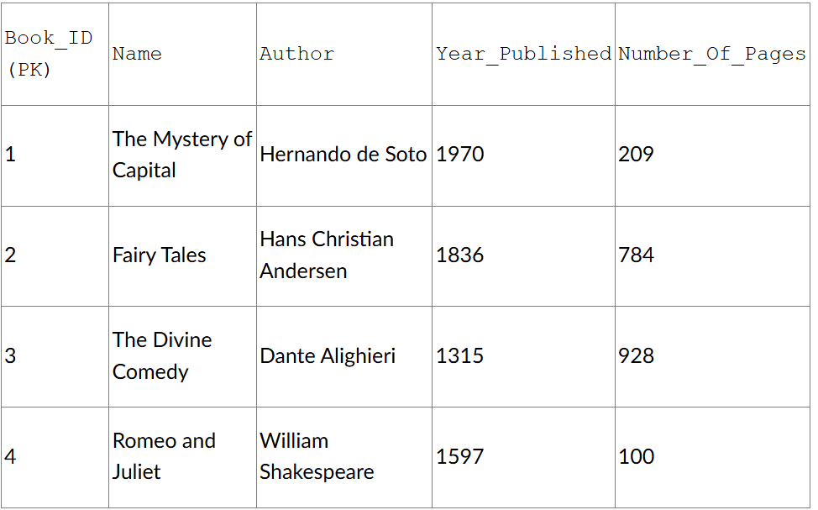

* 1. Run the code. Provide a screenshot of this code running in VS Code.

1. Create a file called read.py.
   1. Connect to the Cassandra database in port 9042.
   2. Connect to the books keyspace.
   3. Run a *query* to select all books and print each book.
   4. Print a screenshot of the VS Code and of the output from the code showing the four books.
2. On the Docker desktop, launch the CLI for the Cassandra *container.* Run the cqlsh command.Connect to the books keyspace. Run an insert *statement* to insert the following book into the database:

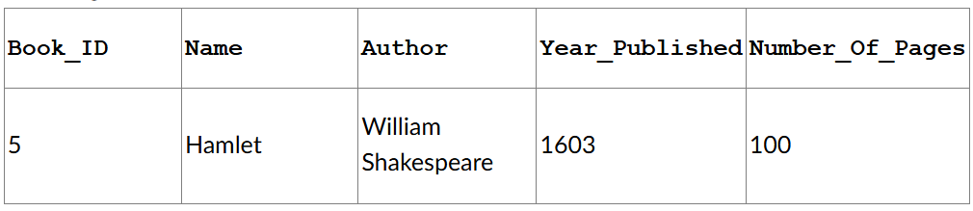

* 1. Print a screenshot of the cqlsh window to show that the book has been added.

1. In the cqlsh window, select all books in the books keyspace. Print a screenshot of the cqlsh window showing the results of the SELECT *statement*.

**Submission Instructions:**

Your submission for this assignment should be a Word document that includes the following screenshots, each labeled for the step that the screenshot represents:

1. Provide a screenshot of your Docker desktop showing the Cassandra *container* running in port 9042.
2. Provide screenshots to show that the write.py file was created in VS Code and that it contains the following required elements:
   1. A keyspace called books.
   2. A table called book that contains the columns and rows defined in the activity instructions.
3. Provide screenshots to show that the read.py file was created in VS Code and that it contains the four books within the books keyspace.
4. Provide a screenshot of the cqlsh window to show that insert *statement* has been run to add the fifth book to the books keyspace.
5. Provide a screenshot of the cqlsh window showing the results of the SELECT *statement* with all books in the books keyspace selected.